SALES FORECASTING PROJECT

DEPARTMENT OF INFORMATION SCIENCES
SCHOOL OF COMPUTING AND INFORMATICS TECHNOLOGY
A Concept Paper submitted to the School of Computing and Informatics Technology
For the Study Leading to a Project Proposal in Partial Fulfillment of the
Requirements for the Award of the Degree of Bachelor of
Software Engineering of Makerere University.

Supervisor
Kamulegeya Grace
gkamuleg@cit.ac.ug

GROUP MEMBERSHIP:

# | Names | Registration Number | Signature
1 | OKELLO TIMOTHY | 17/U/9576/PS
2 | TINDYEBWA FORTUNATE ALLAN | 17/U/10441/EVE
3 | MULUMBA HUZAIFA | 17/U/6545/PS
4 | LUBOWA WANYENZE VIVIEN J | 16/U/6627/PS

Introduction
Sales Forecasting is the process of using a company’s sales records over the past years to predict the short-term or long-term sales performance of that company in the future. This is one of the pillars of proper financial planning. As with any prediction-related process, risk and uncertainty are unavoidable in Sales Forecasting too.
Hence, it’s considered a good practice for Sales forecasting teams to mention the degree of uncertainties in their forecast. Sales Forecasting is a globally-conducted corporate practice where a number of objectives are identified, action-plans are chalked out as well as budgets and resources are allotted to them.
The first step to proper Sales Forecasting is to know the things that fall within your domain directly as a salesperson. This usually relates to your sales staff, clients and prospects. Other factors to consider during the setup of a forecast are the negative ones like − uncertainty, abrupt changes in consumer shopping patterns, etc.
One of the most common yet basic challenges that the management of companies face in making business sales forecasts is that their usual approach is a “top to down” one. This approach leaves very little scope for interaction with the sales manager and the salespersons during the data collection process.

Background to the Problem
The dataset is BigMart dataset obtained from KAGGLE. The obtained dataset is structured i.e. It can be traversed easily and an item can be easily searched and got because it is presented in an orderly and organized manner.
Some features of the dataset have missing values which will be addressed during data wrangling process i.e. data cleaning basically
There are twelve features contained in the dataset and these include:
item_identifier : which contains data that is numeric type
item_weight: which contains data that is numeric type
item_fat_content: which contains data that is categorical type
item_visibility: which contains data that is numeric type
item_type: which contains data that is categorical type
item_MRP: which contains data that is numeric type
outlet_identifier: which contains data that is numeric type
outlet_establishment_year: which contains data that is numeric type
outlet_size: which contains data that is categorical type
outlet_location_type: which contains data that is categorical type
outlet_type: which contains data that is categorical type
item_outlet_sales: which contains data that is numeric type
Problem Statement
Bigmart is a big supermarket chain, with stores all around the country and its current board set out a challenge to all Data Scientist out there to help them create a model that can
predict the sales, per product, for each store. BigMart has collected sales data from the year 2013, for 1559 products across 10 stores in different cities. With this information the corporation hopes we can identify the products and stores which play a key role in their sales and use that information to take the correct measures to ensure success of their business.
Objectives
The objectives of carrying out the project include:
To set the sales target, the primary purpose of sales forecasting is to establish sales performance goals for the organization. With such a target, the organization will improve on its services to hit it.
To help BIGMART focus only on revenue generating products and stores rather than dealing with non-beneficial products too
To predict expenses, it will help in predicting the expenses and planning budget. It is also be useful in preparing credit policy for BIGMART.
Methodology
In the first place, we shall do data cleaning in order to get rid of the missing gaps and the outliers.
Feature scaling will also be done in order to modify the existing variables and introduce new ones if need be.
Finally we will build predictive models on the data to do the sales forecasting. Through use of machine learning algorithms such as;
Linear regression and logistic regression will be used for this kind of problem where we can easily fit a line of high sale and low sale product, quarters and zone for a product as shown below.
In this case, we shall use Item_Visibility , Item_Type , OutletSize , Outlet_Location_Type ,
Outlet_Type as the major factors that affect the item_outlet_sales in this case which is our target varible
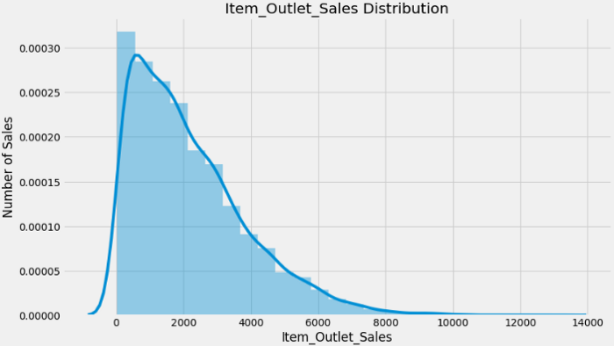
Python based Computer Vision and Deep Learning libraries will be exploited for the development and experimentation of the project. Tools such as Anaconda Python, and libraries such as, Numpy, Scipy, pandas, sklearn, will be utilized for this process.
Outcomes
This project will use regression models to predict sales of different products for the given store based on a time series data for that company. Sales personnel will therefore use this prediction which will be in tabular format to make decisions on which product to stock and not stock in order to maximize profits and minimize costs at a certain trade period.
The final model that will be developed will be used to predict sales of a given product and store.
References
The ultimate guide to sales forecasting by HubSpot
https://blog.hubspot.com/sales/sales-forecasting
Forecasting methods by corporate finance institute
https://corporatefinanceinstitute.com/resources/knowledge/modeling/forecasting-methods/

